SSRS support multiple value parameter, however, when you use multiple value parameter in data driven subscription. You will come across issue.

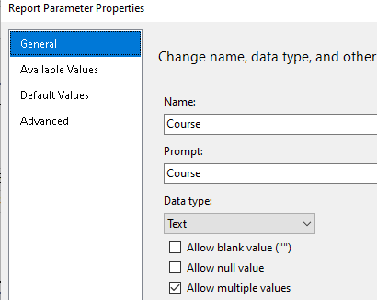

I have tried to use comma separated string like courseA,courseB in data driven subscription setting. It will simply run into error when subscription run.

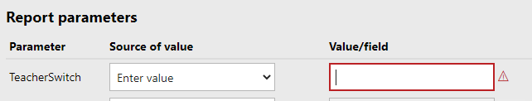

This is has been issue for a long time since multiple parameter option is available, but Microsoft still did not fix it since the report expect multiple columns when there is multiple value for a given param based on this discussion.

https://social.msdn.microsoft.com/Forums/windows/en-US/b2c50aea-2032-4025-a155-306c00fcb856/how-to-pass-multivalue-parameters-to-dds-data-driven-subscription?forum=sqlreportingservices

There has been some work around for this issue. Noticablely, someone has altered the report parameter to let them has default value. Therefore, when you choose source of value from above data driven subscription setting, you can use option using default value. Unfortunately, I cannot find a simple working example online to follow.

I decide to design a simple experiment (or you can call POC in business world) to prove it is working.

Let us first make some data for this testing purpose.

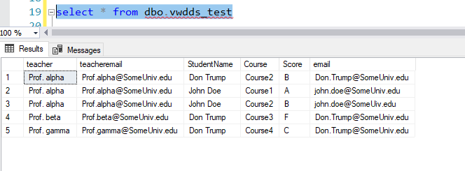

We have teacher, student and score. Let us assume the report is using course as only param to show one or more course and other info (you can use teacher course cascading param, but in this case, I intentionally use only course param, force us to use multiple value for this param) . Notice that prof. alpha teaches two courses, course1 and course2. We would like to send him email with both course together instead of two emails. This will need to provide >1 parameter value to report when schedule the DDS.

Let us first make ssrs report work

Create course dataset like so

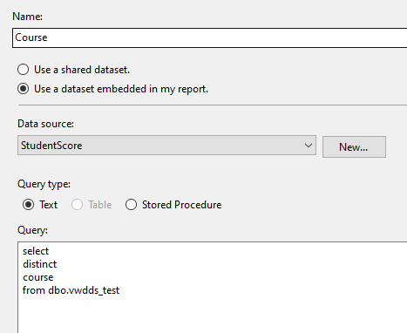

Then create a parameter, configure like this, notice allow multi value is checked

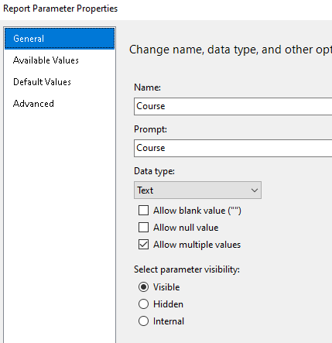

Available values

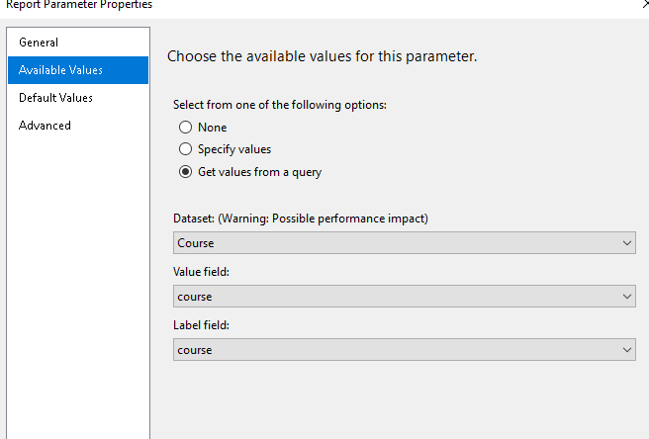

For main report dataset

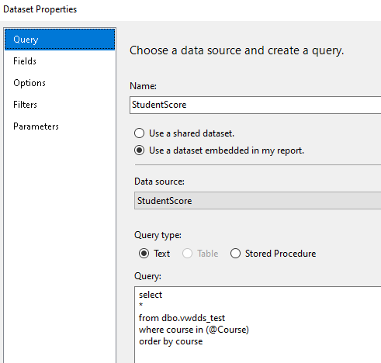

You can see the specific syntax when use multiple value param.

Let us run report. It allow you to select param values.

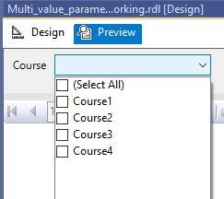

If we choose 3 courses

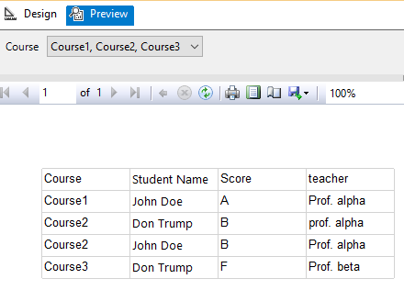

Let us see whether it works on the data driven subscription.

Create dataset for dds

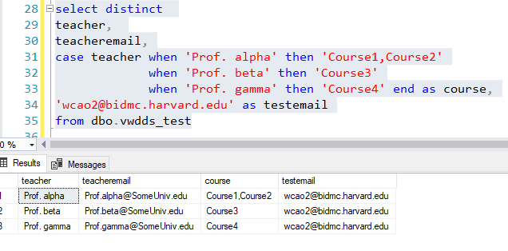

Use course column for course param.

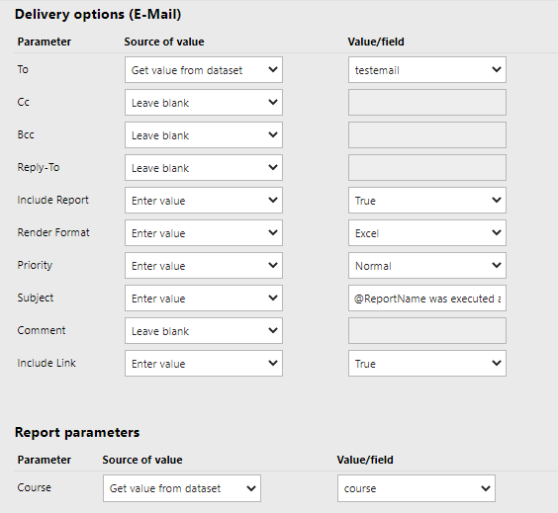

Run result, one process has error, which is comma separate string. Passing combined string won’t work.

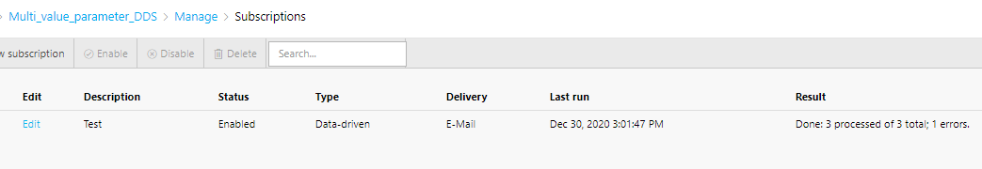

Now, we work on solution 2. We add a hidden param, which is teacher, work as a switch.

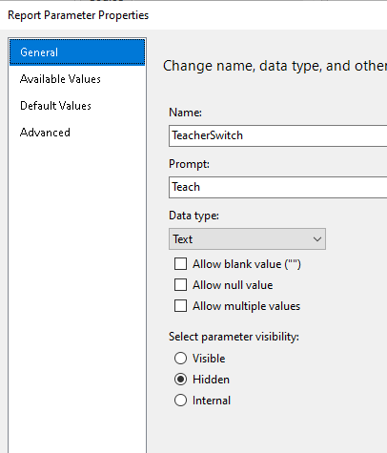

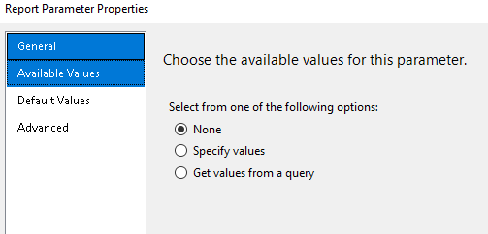

In this case, I default it as all value to include all course.

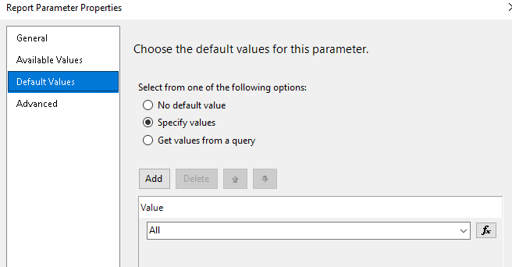

Create a dataset, so that course will have default value. Notice here, if hidden pararm TeacherSwitch = All, I will have teacher = teacher, this will be always true. Therefore include all record, otherwise, it will fiter by the passed in teacherswitch variable.

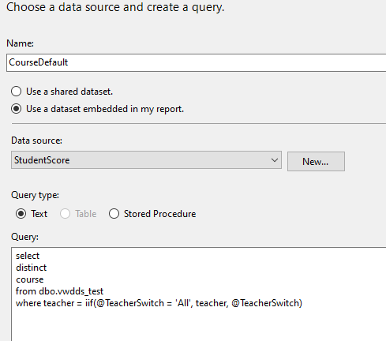

Set the course default value from this dataset.

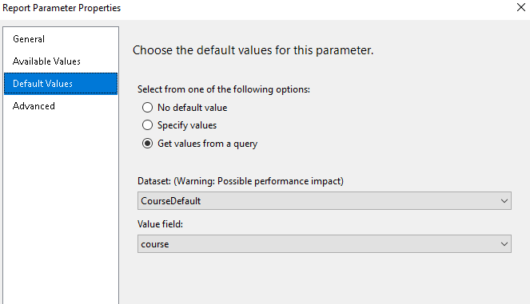

Let us give a run. It will automatically run with all courses. But you can modified it to only select subset of course if you like in second run.

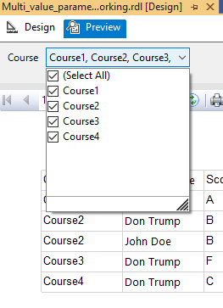

Now let us see how we do DDS.

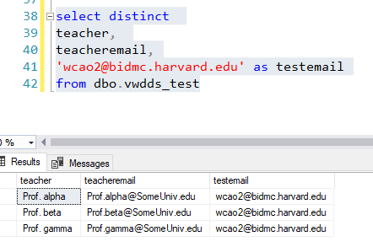

In this case, we set like this, course using default value, we have 3 row in dds dataset.

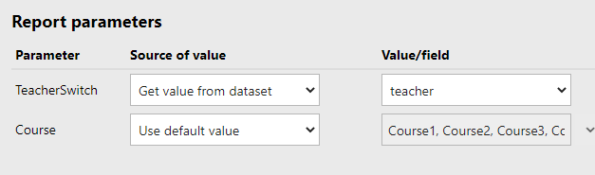

Dds run, all successful.

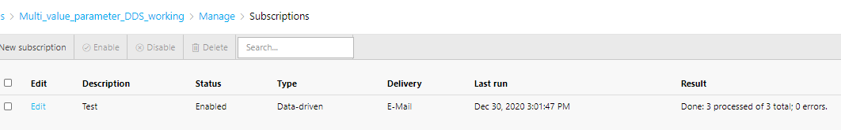

Let us see if prof. alpha has luck to receive all his scores., yes, indeed it is all in one email with 2 courses.

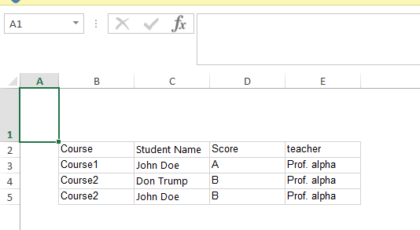

When I test it, I set it use testemail, which point to me. Now everything is set to go, you just need to switch to teacheremail. You are all set.

This POC shows that we can add a hidden param to solve first param multi-value dds issue. This does need set default value to the first param, but it avoid to provide the value in the fly (which is not possible by the way). It did not cause much of inconvenience, just need to select different value if you want to run different parameter set.

Sql code and both working and non working SSRS included. Personal info were changed to protect privacy.

I hope this is helpful to help you avoid hassle to set up tons of regular subscription, which is very hard to manage and maintain for lazy/smart developer.